Scripting Task
Task Description:
- Create a shell script to print the HTTP error code of guvi.in & print, the success/failure message based on the error code response

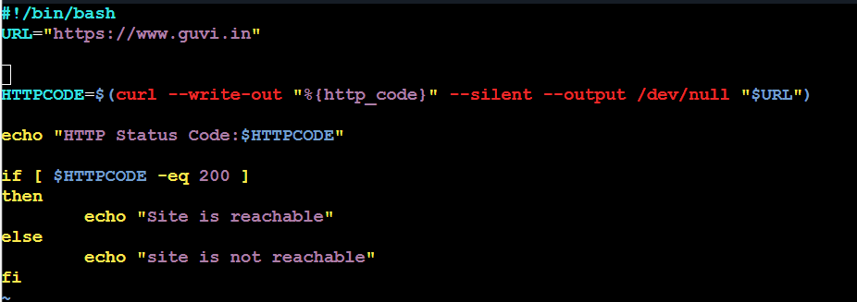

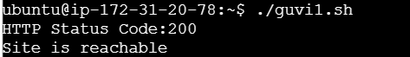

- Given a file, replace all occurrence of the word "give" with "learning" from 5th line till the end in only those lines that contain the word "welcome"

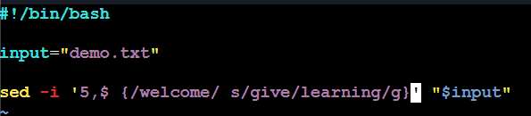
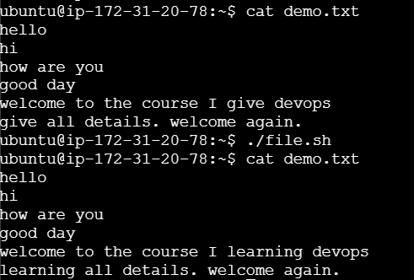

sed -i '5,$ {/welcome/ s/give/learning/g}' "$input"

i – modifies the original file directly
‘5,$ - from 5th line till last line ($ means last line)
/welcome/ -will substitute the words only when welcome presents
s - substitue
/give/learning/ - replace ‘give’ with ‘learning’
g – replace all occurence

